
Aro Tūranga | Position Description

Te Kura Mahi ā-Hirikapo | School of Psychology, Speech and Hearing

Pūkenga | Lecturer
November 2025

Te Tūranga | The Role
A Lecturer has expertise in a specific discipline-related area, is proficient in teaching and is developing their pedagogical practice. They are active in research/scholarship/creative work and building their research portfolio.
A Lecturer is involved in the broader work of the School, including taking on administrative roles that support the achievement of strategic and operational objectives.

Ngā Uara | Our Values
We value manaakitanga, whanaungatanga, and tiakitanga at Te Whare Wānanga o Waitaha and these uara (values) guide our decisions and behaviour. Our values provide a roadmap for how we do things, affirming our commitment to the orange (heath, safety and wellbeing) of our students through mana-enhancing pastoral care and support. Ngā Uara challenge and inspire us to be the best we can be. They make UC a great place to work and study.
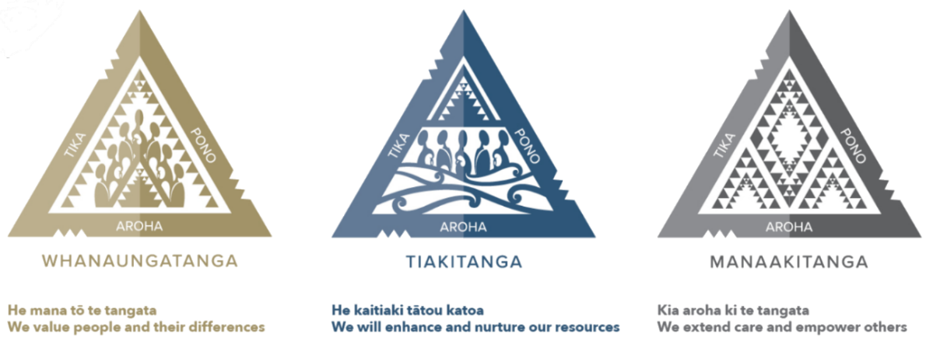

Kawenga Takohanga | Key Accountabilities
These Key Accountabilities provide a representative summary of the major responsibilities for this position. They are not minimum standards and some may be aspirational, for example when new to the role. The Key Accountabilities should inform Professional Development objectives and individual goals as discussed in the University’s Professional Development and Review process.

Teaching
Outcome: A stimulating, research-led and supportive learning environment is created in which students have the opportunity to maximise their academic potential with the aim of developing intellectual independence.
Key responsibilities include:
- Design and deliver high quality teaching and support by utilising innovative, inspirational and proven pedagogical practices that stimulate learning.
- Ensure programmes of study are up to date and leading-edge, reflecting a depth and breadth of discipline expertise and are appropriately assessed through evidence-based quality assurance. This is informed by collaboration across programmes of study.
- Design and deliver appropriate student assessments and provide effective and timely feedback.
- Course and teaching evaluation and feedback opportunities are identified and regularly undertaken. Feedback and critical self-reflection is proactively used for ongoing development.
- Embed the Graduate Profile through your teaching, programmes and services.
- Encourage students to think critically and analytically and provide them with the skills to research and communicate outcomes effectively.
- Engage in Professional Development activities and research to continuously develop and inform your teaching practice and utilisation of innovative technologies.
Research/Scholarship/Creative Work
Outcome: High quality, innovative and valued research is designed, conducted, disseminated and utilised.
Key responsibilities include:
- Establish a research agenda and identify and seek external support and funding.
- Contribute to research environments within and beyond your immediate research group.
- Develop a research portfolio that enriches undergraduate and postgraduate programmes of study.
- Develop and sustain constructive relationships that support research effectiveness, opportunities and discipline reputation.
- Deliver original research outputs through scholarship utilising appropriate media including publications and/or creative works.
- Attract, support and guide postgraduate students with research development and to research degree completion.
- Explore and develop ways to ensure that your research contributes to positive social, cultural, economic, technological and/or legal change.
- Contribute to initiatives on research policy, reviews and funding bodies, and professional discipline societies.

Service
Outcome: UC's strategic objectives, day-to-day activities and reputation is enhanced and well supported by our academic community.
Key responsibilities include:
- Be accessible to students to provide timely advice that reflects diverse needs.
- Take opportunities to be involved in the wide range of activities available to promote collegiality, citizenship and UC reputation. For example: participation and engagement in Student Orientation; staff recruitment activities; Department/School/Faculty/UC Committees; student-led activities.
- Advance UC’s reach and reputation by creating and undertaking opportunities to serve at national levels. For example: Outreach and student recruitment activities; Alumni events; conferences; advisory boards; media interviews, expert opinions and advice.
- Undertake academic review opportunities to support course and year-level reviews and reforms by engaging in quality assurance mechanisms and external moderation as required.
- Support the University to meet its obligations under the Education Act 1989 - to advance learning and knowledge, ensure research and teaching are closely interdependent, meet international standards of research and teaching, be a repository of knowledge and expertise, and undertake the role of critic and conscience of society.

Tangata Tū, Tangata Ora | Engaged, Empowered, Making a Difference
Outcome: Te Whare Wānanga o Waitaha achieves its objectives through a constructive, supportive, and collaborative culture that includes and empowers all members of the UC whānau.
Key responsibilities include:
- Actively demonstrate, exemplify, and live Ngā Uara | the university values, embedding and promotion these in interactions with colleagues, students, and stakeholders.
- Respect and enact the Office of Treaty Partnership Triennial Plan and Te Tiriti o Waitangi.
- Embody UC’s commitment to inclusiveness, participation, recognition, support, and sense of connection and belonging for all students and Faculty.
- Positively contribute to and reinforce UC’s commitment to Health, Safety and Wellbeing by reinforcing an environment that is safe and supportive for you, colleagues, students, contractors, and visitors; engage with and follow the University’s documentation, in addition to Health and Safety legislation; and taking care, responsibility, and prompt action at all times.
- Contribute to the sustainability efforts of UC through the responsible use of resources and equipment.
- Maintain knowledge of UC’s Risk Management Framework, including identifying critical issues and risks and ensuring that these are constructively raised and addressed.
- Participate in projects and other duties as requested to support UC’s success.

Māngai Whakahaere | Reporting/Authority

Reporting Relationships
- Responsible to: Executive Dean
- Reports to: Head of School
- Responsible for: Nil

Financial – Budgetary and Expenditure Limits
In accordance with the Education and Training Act 2020, Te Kaunihera o Te Whare Wānanga o Waitaha | University Council and the Tumu Whakarae | Vice-Chancellor are able to assign powers to delegates, who are authorised to take any action or sign any document (subject to any legal requirements and/or protocols of the University) within the authority of the delegation/s they hold. For financial transactions, individual delegation limits apply depending on each employee’s role and seniority.

Kaupeka Utu | Salary Range
The starting salary is negotiable and is dependent on relevant skills, qualifications and experience of the successful applicant in accordance with the UC Academic Staff, Associated Staff, and Academic Support Staff Collective Employment Agreement.

Wheako me ngā Pūkenga | Experience and Skills
- Expert knowledge in subject area of Human Factors Psychology.
- Understanding of student learning and effective teaching methods.
- Experience participating in quality research programmes.
- Excellent application of Information Technology skills.
- Evidence of reputation within discipline.
- Demonstrated understanding of, and experience in, delivering effective teaching methods that enable a wide range of learners to succeed.
- Experience of participating in innovative research programmes.
- Evidence of the development of a research portfolio.
- Evidence of reflective learning and continuous professional development.
- Active commitment to UC values, tikanga (protocols and processes), kawa of cultural practice and traditions as guided by mana whenua and valuing te reo Māori.
- Competency in te reo Māori me ōna tikanga is an advantage.

Mātauranga | Education
- PhD in Psychology or equivalent in a relevant field (NZQA Level 10), desirable

Whakangungu | Professional Development and Review (PD&R)
The University is committed to developing its staff. As part of this commitment a Professional Development and Review Process (PD&R) is undertaken regularly between you and your manager. This is to discuss and agree objectives and opportunities for your professional development and identify how these plans will contribute to the achievement of the University’s objectives.

